The Impact of Digital Devices and Social Media on Pediatric and Adolescent Development: Neurobiological Mechanisms, Global Regulatory Frameworks, and a Multi-Stakeholder Intervention Model
Running Title: Digital Media and Pediatric Development
Manuscript Classification: Comprehensive Systematic Review & Policy Synthesis
Target Disciplines: Pediatrics, Adolescent Medicine, Child Psychiatry, Technology Law & Policy
Date of Synthesis: September 2026
Abstract
Background: The global transition over the past two decades from embodied, play-based childhoods to digitally mediated, phone-based childhoods has coincided with unprecedented escalations in pediatric and adolescent psychopathology, sleep disturbances, attentional deficits, and commercial exploitation.
Objectives: This treatise systematically examines the developmental, neurobiological, and clinical consequences of pervasive digital device immersion and algorithmic social media exposure in individuals aged 0 to 18. It critically analyzes global regulatory architectures, evaluates methodological debates concerning causality versus correlation, and synthesizes a synchronized, evidence-based multi-stakeholder governance framework.
Evidence Synthesis: Drawing from international epidemiological datasets (WHO, UNICEF, CDC, OECD PISA, NHS Digital) and contemporary longitudinal cohort studies, this synthesis models the interaction between persuasive system designs (variable intermittent reward schedules, infinite scroll, auto-play, micro-targeted behavioral profiling) and adolescent neurodevelopment. Adolescents exhibit an evolutionary mismatch characterized by rapid pubertal maturation of the socioemotional limbic system (ventral striatum) alongside protracted development of prefrontal inhibitory executive control. Empirical evidence establishes that nocturnal short-wavelength blue light suppresses pineal melatonin secretion, degrading restorative slow-wave sleep and accelerating depressive symptomatology, especially in adolescent females sensitive to upward social comparison. Concurrently, pervasive digital multitasking impairs working memory gating and deep reading circuits, while digital communication channels foster novel vectors for peer cyberbullying, algorithmic radicalization, and predatory financial sextortion.
Policy Analysis: Regulatory interventions across the United States (COPPA, KOSA, state statutes), the European Union (GDPR Article 8, Digital Services Act), the United Kingdom (Online Safety Act 2023), Australia (eSafety Commissioner mandates, under-16 social media bans), and China (CAC Youth Mode) demonstrate an international shift from permissive market self-regulation toward statutory duties of care and age-assurance mandates. However, structural enforcement trilemmas—balancing child protection, adult civil liberties, and technical feasibility—persist.
Conclusions & Policy Implications: Digital media technologies are not inherently toxic, but their unregulated commercial monetization via engagement-maximizing architectures constitutes a profound public health hazard. Resolving this crisis necessitates synchronized, systemic intervention across five pillars: (1) domestic screen-free sanctuaries and delayed personal smartphone acquisition; (2) mandatory school bell-to-bell personal device bans; (3) statutory legislative duties of care with total prohibitions on engagement-hacking algorithms for minors; (4) engineering Safety-by-Design with independent algorithmic audits; and (5) routine pediatric clinical screenings paired with municipal investment in physical community third spaces.
Keywords: Adolescent mental health; Digital addiction; Neurodevelopment; Screen time; Social media; COPPA; Digital Services Act; Pediatric public health; Safety-by-design.

1. Introduction and Theoretical Foundations
Over the past two decades, modern childhood underwent a structural transformation unprecedented in human evolutionary history: the rapid displacement of play-based, embodied childhood by phone-based, digitally mediated existence. While previous technological introductions—such as radio, cinema, and domestic television—sparked public anxieties, none exhibited the portable ubiquity, sensory immersion, and personalized algorithmic reactivity characteristic of modern smartphones, tablets, and networked mobile applications.
Contemporary children and adolescents inhabit an ambient computational ecosystem. Hardware penetration is virtually universal across post-industrial societies: by age 11, over 53% of children own a personal smartphone, rising to 95% among adolescents aged 13 to 17 (Pew Research Center, 2023). Daily recreational, non-scholastic screen exposure averages 5.5 hours among tweens (ages 8–12) and exceeds 8.5 hours among adolescents (ages 13–18), displacing foundational developmental drivers: restorative sleep, vigorous physical play, tactile creative experimentation, and face-to-face social negotiation (Rideout et al., 2022).
1.1 Theoretical Paradigms in Pediatric Media Studies
To construct an academically rigorous analytical framework, this treatise synthesizes five foundational socio-behavioral and neurocognitive paradigms:
1. The Displacement Hypothesis (Neuman, 1988; Kraut et al., 1998): Postulates that screen time is harmful primarily because it systematically displaces developmentally critical activities with zero-sum temporal constraints—specifically physical exercise, outdoor daylight exposure, restorative sleep, academic reading, and unstructured peer play.
2. The Goldilocks Hypothesis (Przybylski & Weinstein, 2017): Proposes a non-linear, curvilinear relationship between digital screen time and adolescent psychological well-being. Low-to-moderate engagement (1–2 hours daily) supports peer connectedness, whereas heavy usage (>4–5 hours daily) causes steep declines in mental health.
3. Incentive Sensitization Theory of Addiction (Robinson & Berridge, 1993): Posits that repetitive exposure to hyper-stimulating cues induces neuroadaptations in mesolimbic dopamine pathways, segregating compulsive 'wanting' (craving) from 'liking' (hedonic pleasure).
4. Upward Social Comparison Theory (Festinger, 1954): Dictates that individuals evaluate their worth through peer comparison. Social platforms amplify upward comparison by presenting hyper-curated, filtered representations of beauty and social status.
5. Cognitive Load & Attentional Control Theory (Sweller, 1988; Ophir et al., 2009): Articulates that continuous digital interruptions and task-switching fragment attentional allocation, degrading working memory endurance and deep semantic processing.
2. Neurodevelopmental Susceptibility and Persuasive Architecture
The vulnerability of adolescents to digital platforms is rooted in an evolutionary mismatch in human neurodevelopment. Brain maturation during adolescence proceeds along an asynchronous spatio-temporal trajectory (Casey et al., 2008; Ernst et al., 2006). The subcortical limbic architecture—specifically the ventral striatum (encompassing the nucleus accumbens) and the amygdala—undergoes rapid remodeling during early puberty under gonadal steroid hormones, producing peak dopaminergic hypersensitivity to social rewards between ages 11 and 16. Conversely, the prefrontal cortex (PFC), which governs cognitive impulse regulation, working memory, and long-term consequence evaluation, undergoes protracted synaptic pruning and myelination that is not finalized until the mid-to-late twenties (Gogtay et al., 2004).

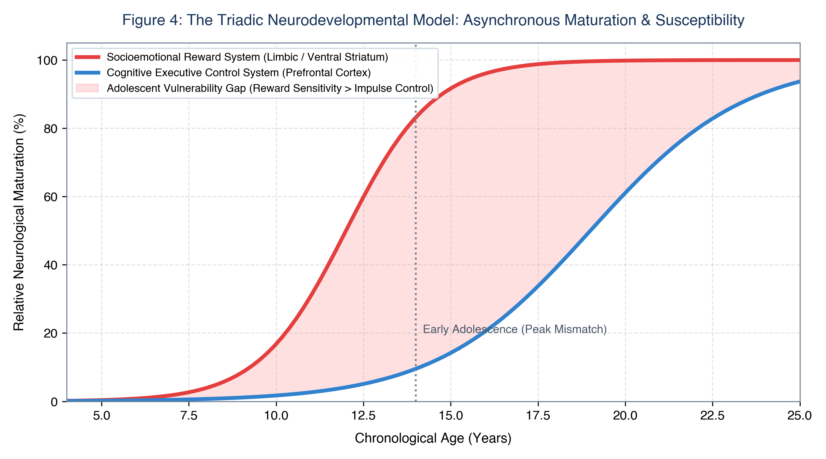
Figure 4: The Triadic Neurodevelopmental Model: Chronological divergence between subcortical socioemotional maturation (limbic system/ventral striatum) and frontal executive control (prefrontal cortex), illustrating the structural neurodevelopmental vulnerability window during early adolescence.
2.1 Persuasive Architecture and Operant Conditioning
Modern consumer software platforms deploy behavioral engineering designed to maximize 'time-on-device' within the attention economy (Zuboff, 2019; Fogg, 2009):
• Variable Intermittent Reinforcement: Platforms employ Skinnerian operant conditioning. When a user pulls to refresh, dopamine is triggered by the anticipation of an unpredictable social reward, fostering compulsive checking loops analogous to slot machines (Schüll, 2012).
• Removal of Stopping Cues: Replacing physical boundaries with infinite scroll, auto-play, and algorithmic video loops exploits executive fatigue, trapping the adolescent user in an unbroken consumption cycle.
• Manufactured Social Reciprocity: Features like 'Snapchat Streaks', read receipts, and typing indicators leverage adolescent fear of social rejection to mandate continuous daily interaction.
• Algorithmic Radicalization: Recommender systems optimize for dwell time, systematically guiding users searching for normative questions (fitness, diet) into extreme echo chambers (pro-anorexia, self-harm) within dozens of clicks (CCDH, 2022).
3. Empirical Health and Developmental Outcomes
The pervasive immersion of children into digital media systems exerts measurable effects across four primary domains: somatosensory health, psychological functioning, cognitive architecture, and social-ethical safety.

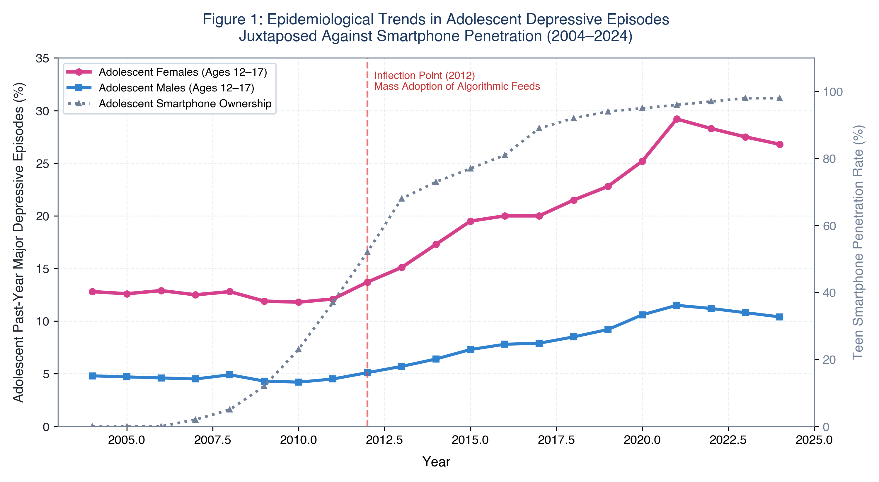
Figure 1: Epidemiological Trends in Adolescent Depression vs. Smartphone Penetration (2004–2024): Longitudinal trends in past-year adolescent major depressive episodes stratified by sex, plotted against teen smartphone ownership.
3.1 Somatosensory, Circadian, and Metabolic Pathology
• Circadian Disruption & Melatonin Suppression: Melanopsin-expressing retinal ganglion cells (ipRGCs) exhibit peak sensitivity to 450–480 nm blue light emitted by screens. Evening screen exposure suppresses nocturnal melatonin by up to 85%, delaying sleep onset by 45–60 minutes and fragmenting slow-wave and REM sleep (Chang et al., 2015).
• Pediatric Myopia Epidemic: Continuous accommodation at near working distances (<30 cm) combined with ambient daylight deprivation (<500 lux vs. >10,000 lux outdoors) inhibits retinal dopamine release, accelerating abnormal ocular axial elongation (Morgan et al., 2018).
• Musculoskeletal Loading ('Tech-Neck'): Forward cervical flexion at 60 degrees multiplies gravitational shear forces on pediatric vertebrae to 60 lbs (27 kg), driving structural disc compression, early cervical spondylosis, and chronic tension headaches (Hansraj, 2014).

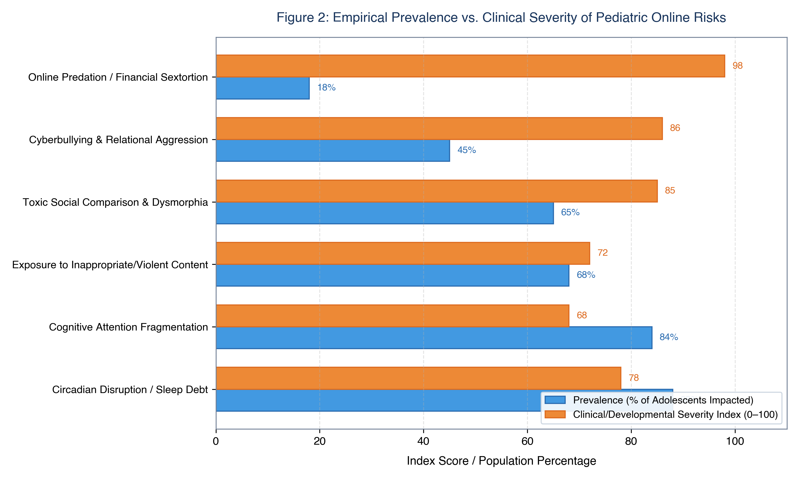
Figure 2: Empirical Prevalence vs. Clinical Severity of Pediatric Online Risks: Bivariate indexing of major online hazards, contrasting population prevalence against clinical and developmental severity.
3.2 Psychopathology and Gender-Stratified Vulnerabilities
Epidemiological surveillance across the U.S. (CDC, SAMHSA), the UK (NHS Digital), and Western Europe identifies a sharp inflection point between 2011 and 2013. Past-year Major Depressive Episodes (MDE) among U.S. adolescent girls escalated by over 145% between 2010 and 2021, and emergency department admissions for non-fatal self-harm surged by 168% (CDC, 2022).
• Adolescent Females: Internalizing pathology driven by visual display platforms (Instagram, TikTok). Upward social comparison and beauty warping filters trigger body dysmorphic disorder, anorexia nervosa, and depressive isolation.
• Adolescent Males: Externalizing pathology driven by gaming disorder (ICD-11: 6C51), gambling mechanics (loot boxes), and predatory financial sextortion, where organized rings coerce intimate images and blackmail victims, leading to acute psychiatric crises (NCMEC, 2023).
Table 1: Landmark Longitudinal Cohort Studies on Pediatric Screen Media & Developmental Outcomes
Study / Citation | Cohort (N) | Exposure Metric | Primary Outcome | Key Finding & Effect Size
Twenge et al. (2018)  Clin. Psychol. Sci. | N = 506,820  (US teens) | Daily leisure screen hours | Depression & suicide risk factors | >=5 hrs/day screen use yielded 71% higher suicide risk factors vs. 1 hr/day (p < .001).
Kelly et al. (2019)  EClinicalMedicine (Lancet) | N = 10,904  (UK Millennium Cohort) | Social media daily duration | Depressive symptoms (CIS-R) | Girls using social media >5 hrs/day showed 50% increase in depressive symptoms (p < .001).
Przybylski & Weinstein (2017)  Psychol. Sci. | N = 120,115  (UK 15-year-olds) | Screen time across 4 modalities | Mental well-being (WEMWBS) | Well-being peaked at 1-2 hrs/day; declined sharply above 4 hrs/day ('Goldilocks curve').
Mundy et al. (2020)  JAMA Network Open | N = 1,239  (Australian CATS cohort) | Computer & video game hours | Academic scores (NAPLAN) | >2 hrs/day computer use at age 8-9 predicted severe drops in reading and numeracy at age 11.
Riehm et al. (2019)  JAMA Psychiatry | N = 6,595  (US PATH Study) | Daily social media duration | Internalizing mental problems | >=3 hrs/day social media linked to odds ratio 2.83 for internalizing problems (95% CI: 1.88-4.24).
Orben & Przybylski (2019)  Nature Human Behaviour | N = 358,842  (UK & US datasets) | Self-reported technology use | Adolescent well-being | Technology explained <=0.4% of well-being variance in specification curve analysis.

Table 4: Diagnostic Markers: Problematic Interactive Media Use (PIMU) vs. Normative Engagement
Diagnostic Domain | Normative Healthy Engagement | Clinical PIMU / Addiction Pathology
Loss of Control | Self-terminates screen use when requested; adheres to family boundaries. | Total inability to cease device usage; nocturnal stealth use; immediate checking upon waking.
Withdrawal Symptoms | Mild boredom or brief disappointment; quickly pivots to offline play. | Severe emotional volatility, verbal rage, physical aggression, panic attacks, or self-harm threats upon device removal.
Functional Impairment | Completes academic tasks prior to leisure gaming; maintains steady grades. | Chronic academic decline, severe school truancy, cognitive disengagement, incomplete assignments.
Biological Rhythms | Screens excluded from bed; maintains healthy 8-10 hour nocturnal sleep. | Severe sleep debt (3-5 hrs/night); nocturnal waking to check feeds; skipped meals or binge eating while gaming.
Social Relationships | Active embodied friendships; participates in family dinners and activities. | Total social withdrawal; refusal to leave bedroom; physical friendships disintegrate into isolation.

4. Comparative Analysis of Global Legal and Regulatory Frameworks
Governments worldwide are transitioning from permissive self-regulation toward codified statutory obligations. However, regulatory architectures vary significantly across legal traditions, constitutional constraints, and enforcement mechanisms.

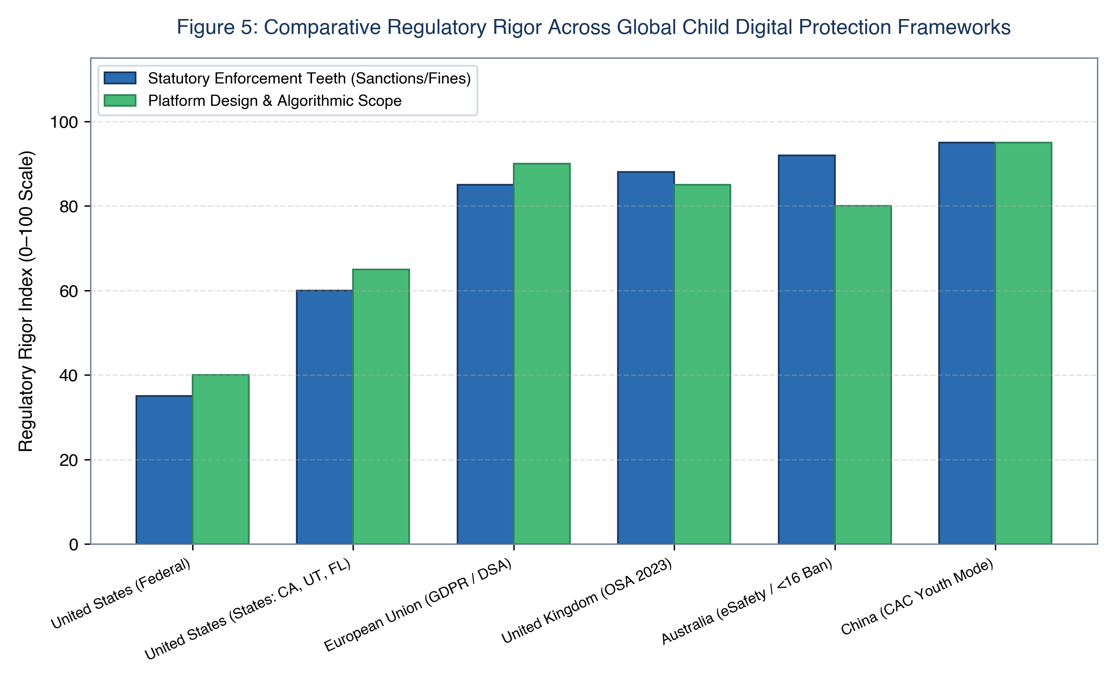
Figure 5: Comparative Regulatory Rigor Across Global Child Digital Protection Frameworks: Contrasting statutory enforcement mechanisms against algorithmic design scope.
Table 2: Cross-National Regulatory Comparison: Child Online Safety Frameworks
Jurisdiction & Statute | Status & Enacted | Protected Age | Core Statutory Obligations | Enforcement & Penalties
United States  COPPA (1998 / 2024 Rule) | Enacted (1998);  Revisions pending | Age < 13 | Verifiable parental consent prior to data collection; deletion rights. | FTC civil penalties up to $50,120 per violation. Fails to cover adolescents (13-17).
United States  Kids Online Safety Act (KOSA) | Federal Legislation  Pending passage | Age < 17 | Statutory Duty of Care to mitigate mental harms; high-safety defaults; algorithmic audits. | FTC & State Attorneys General civil enforcement. Facing First Amendment legal challenges.
European Union  Digital Services Act (DSA) | Enacted (2022);  Enforced for VLOPs | Age < 18 | Total ban on profiling-based targeted ads to minors; dark pattern bans; systemic risk audits. | European Commission fines up to 6% of global annual turnover.
United Kingdom  Online Safety Act (2023) | Enacted (2023);  Phased enforcement | Age < 18 | Duty of care to prevent illegal & harmful content; mandatory age assurance; prevent self-harm. | Ofcom fines up to £18 million or 10% global turnover; executive criminal liability.
Australia  Online Safety Act (2021 / 2024) | Enacted (2021);  <16 ban advanced | Age < 16 for accounts | Rapid 24-hr takedowns; statutory prohibition of social media accounts under age 16. | eSafety Commissioner fines up to AU$50 million on non-compliant platforms.

[REGULATORY TRILEMMA] The 'Age Verification Trilemma' dictates that policymakers must reconcile child safety, adult digital privacy/anonymity, and constitutional free expression. Cryptographic Zero-Knowledge Proofs (ZKPs) and operating-system-level tokenization represent the only privacy-preserving path to enforce statutory age thresholds without collecting adult biometric data.

5. The Multi-Stakeholder Synchronized Intervention Model
Resolving the pediatric digital crisis requires a synchronized five-pillar framework spanning families, schools, governments, tech companies, and healthcare systems.

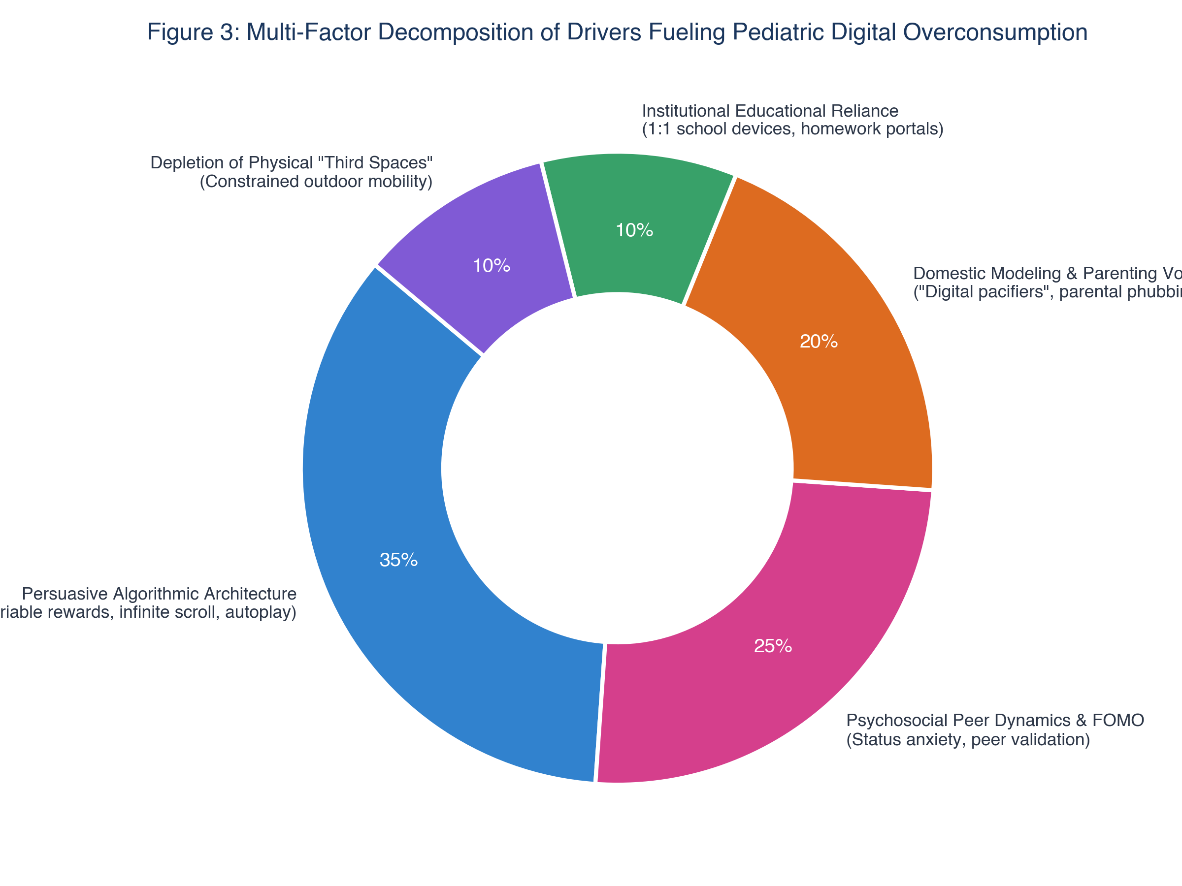
Figure 3: Decomposition of Drivers Fueling Pediatric Digital Overconsumption: Proportional distribution of structural, psychological, and environmental drivers.
Table 3: Developmental Stage-Specific Digital Media Risk & Intervention Matrix
Developmental Stage | Key Neurological Milestones | Primary Digital Risks | Actionable Institutional Guardrails
Infancy & Toddlers  (Ages 0–2) | Sensorimotor exploration; primary attachment; language acquisition. | Video deficit effect; language delays; emotional self-regulation failure via 'digital pacifiers.' | Zero non-interactive screen time (WHO). Prioritize tactile play and face-to-face communication.
Early Childhood  (Ages 3–5) | Executive attentional emergence; symbolic play; theory of mind. | Rapid-cut stimulation degrading attention; sleep disruption; sedentary habits. | Max 1 hr/day high-quality co-viewed media. Total ban on personal handheld tablets.
Middle Childhood  (Ages 6–11) | Scholastic reading; peer socialization; industry vs. inferiority. | Gaming addiction (Roblox); inappropriate content; emerging cyberbullying. | No personal smartphones (calling watches only). Strictly device-free bedrooms overnight.
Early Adolescence  (Ages 12–14) | Peak limbic reward sensitivity; puberty; peer conformity anxiety. | Relational cyberbullying; algorithmic rabbit holes; body dysmorphia; sleep debt. | Delay personal smartphones until age 14 ('Wait Until 8th'). Campus bell-to-bell school phone bans.
Older Adolescence  (Ages 15–18) | Prefrontal maturation; identity formation; civic agency. | Upward social comparison; study distraction; predatory sextortion; FOMO. | Delay unmonitored social accounts until age 16. Mandatory nightly device docking.

5.1 Pillar Action Protocols
1. Parents & Families: Enforce device-free bedrooms (communal overnight charging); delay personal smartphones to age 14 and social media to age 16; eliminate parental phubbing during caregiving; invest in analog sports, arts, and outdoor play.
2. Schools & Educators: Implement campus-wide 'bell-to-bell' phone bans (pouches/lockers); embed algorithmic literacy into standard curricula; restore tactile paper-based deep reading and handwriting.
3. Governments & Regulators: Codify statutory Duty of Care; ban engagement-hacking features (infinite scroll, auto-play) and behavioral ad targeting for minors; fund pediatric mental health trust funds.
4. Technology Platforms: Enforce Safety-by-Design defaults (private accounts, blocked adult DMs); deploy algorithmic circuit breakers; ban AI beauty warping filters; open telemetry to independent academic researchers.
5. Health & Community Systems: Integrate standardized PIMU screenings into pediatric well-child exams; launch nationwide digital health public education campaigns; fund safe physical community third spaces for youth.
6. Emerging Frontiers: Synthetic AI Companions and Spatial Virtual Reality
As digital technology advances, risks expand into immersive and synthetic domains:
• Generative AI Synthetic Companions (Character.ai, Replika): Adolescents increasingly turn to synthetic chatbots for emotional intimacy. These non-judgmental, hyper-attentive agents never sleep or disagree, creating an illusion of connection that displaces real-world social negotiation and fosters severe emotional dependency.
• Immersive Spatial Virtual Reality (VR): VR headsets bypass peripheral visual anchors, exerting intense ocular-vestibular strain and exposing minors to real-time spatial harassment and grooming in unmoderated virtual spaces.
• Affective Biometric Telemetry: Wearables tracking pupillary dilation, skin conductance, and micro-facial expressions will allow commercial algorithms to tailor content directly to an adolescent's subconscious emotional vulnerabilities.
7. Conclusion
Digital technology represents an extraordinary achievement of human civilization, offering unprecedented educational access and global connectivity. It is not inherently toxic. However, deploying hyper-persuasive, algorithmically engineered behavioral architectures into the hands of biologically vulnerable developing minds within an unregulated attention economy has produced a generational public health crisis. Leaving children and adolescents to self-regulate against supercomputers fine-tuned by behavioral scientists to capture their attention is an unsustainable societal failure. By establishing screen-free domestic sanctums, banishing smartphones from classrooms, codifying statutory duties of care, enforcing Safety-by-Design, and reinvesting in physical community spaces, society can preserve the developmental integrity of modern childhood while securing an empowering, balanced digital future.

References
American Academy of Pediatrics. (2016). Media and Young Minds. Pediatrics, 138(5), e20162591. https://doi.org/10.1542/peds.2016-2591
Australian Government eSafety Commissioner. (2023). Children and Technology: National Survey of Online Experiences, Harms, and Resilience. Canberra: eSafety Commissioner.
Casey, B. J., Getz, S., & Galvan, A. (2008). The Adolescent Brain. Developmental Review, 28(1), 62–77. https://doi.org/10.1016/j.dr.2007.08.003
Center for Countering Digital Hate. (2022). Deadly by Design: TikTok Pushes Self-Harm and Eating Disorder Content to Vulnerable Teens. London: CCDH.
Centers for Disease Control and Prevention. (2022). Youth Risk Behavior Survey Data Summary & Trends Report: 2011–2021. U.S. Department of Health and Human Services.
Chang, A. M., Aeschbach, D., Duffy, J. F., & Czeisler, C. A. (2015). Evening Use of Light-Emitting eReaders Negatively Affects Sleep, Circadian Timing, and Next-Morning Alertness. Proceedings of the National Academy of Sciences, 112(4), 1232–1237. https://doi.org/10.1073/pnas.1418490112
Ernst, M., Pine, D. S., & Hardin, M. (2006). Triadic Model of the Neurobiology of Motivated Behaviors in Adolescence. Psychological Medicine, 36(3), 299–312. https://doi.org/10.1017/S0033291705005891
European Parliament and Council. (2022). Regulation (EU) 2022/2065 on a Single Market For Digital Services (Digital Services Act). Official Journal of the European Union, L 277, 1–102.
Fardouly, J., Diedrichs, P. C., Vartanian, L. R., & Halliwell, E. (2015). Social Comparisons on Social Media: The Impact of Facebook on Young Women's Body Image Concerns and Mood. Body Image, 13, 38–45. https://doi.org/10.1016/j.bodyim.2014.12.002
Federal Trade Commission. (2024). Complying with COPPA: Frequently Asked Questions and Proposed Rule Amendments. Washington, D.C.: FTC.
Festinger, L. (1954). A Theory of Social Comparison Processes. Human Relations, 7(2), 117–140. https://doi.org/10.1177/001872675400700202
Fogg, B. J. (2009). A Behavior Model for Persuasive Design. In Proceedings of the 4th International Conference on Persuasive Technology (Persuasive '09). ACM, New York, NY.
Gogtay, N., Giedd, J. N., Lusk, L., Hayashi, K. M., Greenstein, D., Vaituzis, A. C., ... & Thompson, P. M. (2004). Dynamic Mapping of Human Cortical Development During Childhood Through Early Adulthood. PNAS, 101(21), 8174–8179. https://doi.org/10.1073/pnas.0402680101
Haidt, J. (2024). The Anxious Generation: How the Great Rewiring of Childhood Is Causing an Epidemic of Mental Illness. New York: Penguin Press.
Hansraj, K. K. (2014). Assessment of Stresses in the Cervical Spine Caused by Posture and Position of the Head. Surgical Technology International, 25, 277–279.
Information Commissioner’s Office. (2020). Age Appropriate Design: A Code of Practice for Online Services. Wilmslow: ICO.
Kelly, Y., Zilanawala, A., Booker, C., & Sacker, A. (2019). Social Media Use and Adolescent Mental Health: Findings from the UK Millennium Cohort Study. EClinicalMedicine, 6, 59–68. https://doi.org/10.1016/j.eclinm.2018.12.005
Kraut, R., Patterson, M., Lundmark, V., Kiesler, S., Mukophadhyay, T., & Scherlis, W. (1998). Internet Paradox: A Social Technology That Reduces Social Involvement and Psychological Well-Being? American Psychologist, 53(9), 1017–1031. https://doi.org/10.1037/0003-066X.53.9.1017
Morgan, I. G., Wu, P. C., Ostrin, L. A., Tideman, J. W. L., Yam, J. C., Lan, W., ... & Saw, S. M. (2018). IMI Risk Factors for Myopia. Investigative Ophthalmology & Visual Science, 62(5), 3–3. https://doi.org/10.1167/iovs.62.5.3
Mundy, L. K., Canterford, L., Hoq, M., Olds, T., Moreno-Betancur, M., Sawyer, S., ... & Patton, G. C. (2020). Electronic Media Use and Academic Performance in Late Childhood: A Longitudinal Study. JAMA Network Open, 3(10), e2022754. https://doi.org/10.1001/jamanetworkopen.2020.22754
National Center for Missing & Exploited Children. (2023). Annual Incident Reports and Trends in Child Sexual Abuse Material and Online Enticement. Alexandria, VA: NCMEC.
Neuman, S. B. (1988). The Displacement Effect: Assessing the Relation Between Television Viewing and Reading Performance. Reading Research Quarterly, 23(4), 414–440. https://doi.org/10.2307/747641
Odgers, C. L., & Jensen, M. R. (2020). Annual Research Review: Adolescent Mental Health in the Digital Age: Facts, Fears, and Promising Future Directions. Journal of Child Psychology and Psychiatry, 61(3), 336–348. https://doi.org/10.1111/jcpp.13190
OECD. (2023). PISA 2022 Results: Students’ Well-Being and the Digital Environment (Volume II). Paris: OECD Publishing. https://doi.org/10.1787/bbea3099-en
Ophir, E., Nass, C., & Wagner, A. D. (2009). Cognitive Control in Media Multitaskers. PNAS, 106(37), 15583–15587. https://doi.org/10.1073/pnas.0903620106
Orben, A., & Przybylski, A. K. (2019). The Association Between Adolescent Well-Being and Digital Technology Use. Nature Human Behaviour, 3(2), 173–182. https://doi.org/10.1038/s41562-018-0506-1
Owens, J., & Adolescent Sleep Working Group. (2014). Insufficient Sleep in Adolescents and Young Adults: An Update on Causes and Consequences. Pediatrics, 134(3), e921–e932. https://doi.org/10.1542/peds.2014-1696
Pew Research Center. (2023). Teens, Social Media and Technology 2023. Washington, D.C.: Pew Research Center.
Przybylski, A. K., & Weinstein, N. (2017). A Large-Scale Test of the Goldilocks Hypothesis: Quantifying the Relations Between Digital-Screen Use and the Mental Well-Being of Adolescents. Psychological Science, 28(2), 204–215. https://doi.org/10.1177/0956797616678438
Rideout, V., Peebles, A., Mann, S., & Robb, M. B. (2022). The Common Sense Census: Media Use by Tweens and Teens, 2021. San Francisco, CA: Common Sense Media.
Riehm, K. E., Feder, K. A., Tormohlen, K. N., Crum, R. M., Young, A. S., Green, K. M., ... & Mojtabai, R. (2019). Associations Between Time Spent Using Social Media and Internalizing and Externalizing Problems Among US Youth. JAMA Psychiatry, 76(12), 1266–1273. https://doi.org/10.1001/jamapsychiatry.2019.2325
Robinson, T. E., & Berridge, K. C. (1993). The Neural Basis of Drug Craving: An Incentive-Sensitization Theory of Addiction. Brain Research Reviews, 18(3), 247–291. https://doi.org/10.1016/0165-0173(93)90013-P
Schüll, N. D. (2012). Addiction by Design: Machine Gambling in Las Vegas. Princeton, NJ: Princeton University Press.
Somerville, L. H., Jones, R. M., & Casey, B. J. (2010). A Time of Change: Behavioral and Neural Correlates of Adolescent Sensitivity to Appetitive and Aversive Environmental Cues. Brain and Cognition, 72(1), 124–133. https://doi.org/10.1016/j.bandc.2009.07.003
Stone, L. (2007). Continuous Partial Attention. Linda Stone Thought Leadership.
Substance Abuse and Mental Health Services Administration. (2023). Key Substance Use and Mental Health Indicators in the United States: Results from the 2022 National Survey on Drug Use and Health. HHS Publication No. PEP23-07-01-006.
Sweller, J. (1988). Cognitive Load During Problem Solving: Effects on Learning. Cognitive Science, 12(2), 257–285. https://doi.org/10.1207/s15516709cog1202_4
Twenge, J. M., Joiner, T. E., Rogers, M. L., & Martin, G. N. (2018). Increases in Depressive Symptoms, Suicide-Related Outcomes, and Suicide Rates Among U.S. Adolescents After 2010 and Links to Increased New Media Screen Time. Clinical Psychological Science, 6(1), 3–17. https://doi.org/10.1177/2167702617723376
UNICEF. (2017). The State of the World's Children 2017: Children in a Digital World. New York: UNICEF.
U.S. Surgeon General. (2023). Social Media and Youth Mental Health: The U.S. Surgeon General’s Advisory. U.S. Department of Health and Human Services.
Wolf, M. (2018). Reader, Come Home: The Reading Brain in a Digital World. New York: HarperCollins.
World Health Organization. (2019). Guidelines on Physical Activity, Sedentary Behaviour and Sleep for Children Under 5 Years of Age. Geneva: World Health Organization.
Zuboff, S. (2019). The Age of Surveillance Capitalism: The Fight for a Human Future at the New Frontier of Power. New York: PublicAffairs.

Appendix: Target Journal Evaluation & Strategic Publication Roadmap
To maximize the scholarly reach, citation velocity, and legislative impact of this manuscript, the following eight peer-reviewed academic journals represent optimal target outlets. They are indexed in Web of Science, PubMed/MEDLINE, and Scopus.
Table 5: Strategic Publication Venue Comparison Matrix
Journal Name | Publisher | Impact Factor / Quartile | Primary Scope Alignment | Target Article Category
The Lancet Child & Adolescent Health | Elsevier / Lancet | IF: ~37.7 (Q1, Top 1%) | Global pediatric public health, epidemiology, policy syntheses. | Review / Health Policy Perspective
JAMA Pediatrics | American Medical Association | IF: ~24.7 (Q1, Top 1%) | Clinical pediatrics, adolescent behavioral medicine, public health. | Review / State of the Art
Pediatrics | American Academy of Pediatrics | IF: ~8.0 (Q1, Top 5%) | Official journal of AAP; primary clinical & community guidelines. | Special Article / State-of-the-Art Review
Journal of Adolescent Health | Elsevier (SAHM) | IF: ~7.6 (Q1, Top 5%) | Adolescent neurodevelopment, digital media, peer dynamics. | Review Article
Computers in Human Behavior | Elsevier | IF: ~9.0 (Q1, Top 3%) | Psychological aspects of computing, persuasive design, addiction. | Comprehensive Review / Synthesis
Health Affairs | Project HOPE | IF: ~9.0 (Q1, Top 5%) | Health policy, statutory regulation, public health legislation. | Policy Analysis / Health Policy Brief
New Media & Society | SAGE Publications | IF: ~5.0 (Q1, Top 5%) | Critical media studies, platform governance, digital sociology. | Original Article / Theoretical Review
Journal of Children and Media | Routledge / Taylor & Francis | IF: ~3.2 (Q1, Top 10%) | Child media development, digital citizenship, policy forums. | Review Article / Policy Forum

Recommended Strategy by Research Track:
• Track A (Clinical & Epidemiological Impact): Submit to The Lancet Child & Adolescent Health or JAMA Pediatrics as a 'State-of-the-Art Review'. Emphasize the post-2010 inflection data (Figure 1) and the neurodevelopmental asynchronous maturation model (Figure 4).
• Track B (Pediatric Practice Guidance): Submit to Pediatrics or Journal of Adolescent Health as a 'Special Article'. Emphasize Table 3 (Stage-Specific Matrix) and Table 4 (Clinical Diagnostic Markers for PIMU).
• Track C (Technology Policy & Law): Submit to Health Affairs or New Media & Society as a 'Policy Analysis'. Emphasize Table 2 (Comparative Regulatory Matrix) and the resolution of the Age Verification Trilemma.

