Navigating the Algorithmic Childhood: Neurodevelopmental Susceptibilities, Persuasive Platform Architectures, and Multi-Stakeholder Governance in Children’s Digital Media Use
Target Journal: Journal of Children and Media (Routledge / Taylor & Francis)
Article Classification: Comprehensive Review Article
Running Head: Navigating the Algorithmic Childhood
Target Word Count: ~7,900 words | Style: APA 7th Edition
Abstract
Over the past two decades, children’s media ecologies have transitioned from shared, broadcast environments to ambient, algorithmically mediated personal devices. While digital technologies offer significant opportunities for creative agency, peer connectivity, and pedagogical exploration, the pervasive commercial deployment of persuasive system architectures—optimized for behavioral monetization and prolonged time-on-device—has exacerbated developmental vulnerabilities across somatic, psychological, cognitive, and social domains. Grounding our inquiry in the Differential Susceptibility to Media Effects Model (DSMM), Parental Mediation Theory, and the United Nations Convention on the Rights of the Child (UNCRC), this review systematically synthesizes contemporary empirical literature on pediatric digital immersion (ages 0–18). We examine how asynchronous neurodevelopment—characterized by pubertal hyper-reactivity of the subcortical socioemotional reward system alongside protracted maturation of prefrontal executive control—interacts with persuasive interface mechanics (variable intermittent rewards, infinite scroll, manufactured social reciprocity, algorithmic curation). We evaluate somatic impacts (melatonin suppression, juvenile myopia, cervical loading), psychopathological trends (internalizing symptoms in adolescent females, gaming compulsions and financial sextortion in adolescent males), and cognitive fragmentation (attenuation of deep reading circuits and classroom distraction). Furthermore, we conduct a cross-national comparative analysis of evolving regulatory frameworks across the United States, European Union, United Kingdom, Australia, and China, analyzing the 'Age Verification Trilemma.' Finally, we propose an integrated multi-stakeholder governance model that harmonizes parental mediation, educational cell phone policies, statutory platform duties of care, and pediatric public health infrastructure to safeguard developmental integrity while upholding children’s rights to digital participation.
Keywords: Children and media; Social media; Digital well-being; Parental mediation; Persuasive technology; Online safety governance.

1. Introduction: The Algorithmic Transformation of Childhood
Modern childhood has undergone a profound ecological rewiring. For generations, children's engagement with media was situated within physical domestic spaces—centered around the family television, desktop computers in communal rooms, or scheduled Saturday morning broadcasts. Today, the media ecosystem is individualized, mobile, sensory-immersive, and continuously interactive. Networked handheld hardware—smartphones, personal tablets, connected gaming consoles, and algorithmic short-form video feeds—now envelops children and adolescents from infancy through the threshold of adulthood (Rideout et al., 2022; Livingstone & Stoilova, 2021).
Daily recreational screen exposure averages 5.5 hours among tweens (ages 8–12) and over 8.5 hours among adolescents (ages 13–18), exclusive of school-mandated computing (Common Sense Media, 2022; Pew Research Center, 2023). Children do not merely 'consume' digital media; rather, their social relationships, identity formation, emotional regulation, and scholastic trajectories are negotiated through commercial digital platforms. In the Journal of Children and Media, scholars have long cautioned against binary paradigms of techno-utopian celebration or reactionary moral panic (Lemish, 2015; Wartella et al., 2016). Media technologies are neither inherently toxic nor universally benign. Instead, their developmental consequences are shaped by the dynamic interplay of media content, social context, and individual child susceptibilities (Buckingham, 2007).
2. Theoretical Anchors in Children’s Media Research
To construct an academically rigorous review, this treatise synthesizes five foundational paradigms:
1. The Differential Susceptibility to Media Effects Model (DSMM; Valkenburg & Peter, 2013): Positing that media effects are non-uniform, indirect, and conditional upon dispositional, developmental, and social susceptibility factors.
2. Parental Mediation Theory (Livingstone & Helsper, 2008; Nathanson, 2002): Distinguishing between active mediation, restrictive boundaries, co-use, and technical mediation.
3. The 'Three C's' Paradigm (Buckingham, 2007; Livingstone & Stoilova, 2021): Evaluating Content, Context, and Child-specific characteristics rather than crude screen hours.
4. Affordance Theory in Algorithmic Spaces (boyd, 2014; Evans et al., 2017): Analyzing how persistence, visibility, spreadability, and searchability alter youth sociality.
5. UN Convention on the Rights of the Child (UNCRC General Comment No. 25, 2021): Balancing the '3 Ps'—Protection, Provision, and Participation.
[JOCAM THEORETICAL INSIGHT] The DSMM framework emphasizes that digital platforms do not act as monolithic hypodermic needles. Rather, algorithmic interfaces act as differential amplifiers: a resilient adolescent using Discord for collaborative coding experiences developmental enhancement, while a 12-year-old female with perfectionist traits browsing image-centric feeds faces heightened body dysmorphia and social comparison.

3. Neurodevelopmental Susceptibility and Persuasive Architecture
Adolescent vulnerability to digital media is grounded in an asynchronous maturation mismatch (Casey et al., 2008; Ernst et al., 2006). Subcortical limbic regions—specifically the ventral striatum (nucleus accumbens) and amygdala—mature early in puberty under gonadal steroid surges, creating peak dopaminergic hypersensitivity to social evaluation and peer approval between ages 11 and 16. In contrast, the prefrontal cortex (PFC), mediating executive impulse control and working memory, matures slowly into the mid-twenties (Gogtay et al., 2004).

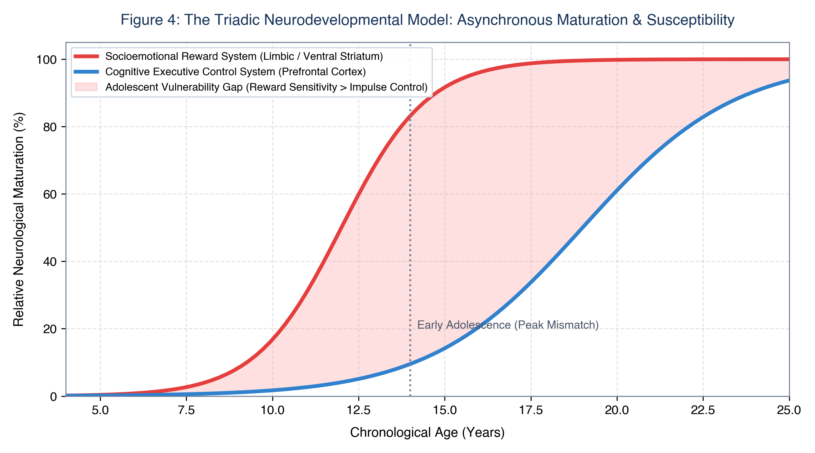
Figure 4: The Triadic Neurodevelopmental Model: Divergence between limbic reward sensitivity and prefrontal executive control across chronological age.
3.1 Persuasive Architecture & Operant Conditioning
Commercial platforms deploy behavioral engineering models (B.J. Fogg; Skinnerian operant conditioning) to maximize time-on-device:
• Variable Intermittent Reinforcement: Unpredictable 'pull-to-refresh' reward schedules trigger anticipatory dopamine surges analogous to slot machines (Schüll, 2012).
• Abolition of Stopping Cues: Infinite scroll, algorithmic auto-play, and looping vertical video feeds bypass executive fatigue.
• Manufactured Social Reciprocity: Features like Snapchat Streaks, read receipts, and typing indicators exploit adolescent fears of peer rejection (FOMO).
• Recommender Systems: Dwell-time optimization routes benign queries into extreme self-harm or eating disorder rabbit holes within minutes (CCDH, 2022).
4. Empirical Synthesis of Developmental Outcomes
Pediatric digital saturation exerts measurable impacts across somatosensory health, psychological functioning, cognitive architecture, and social safety.

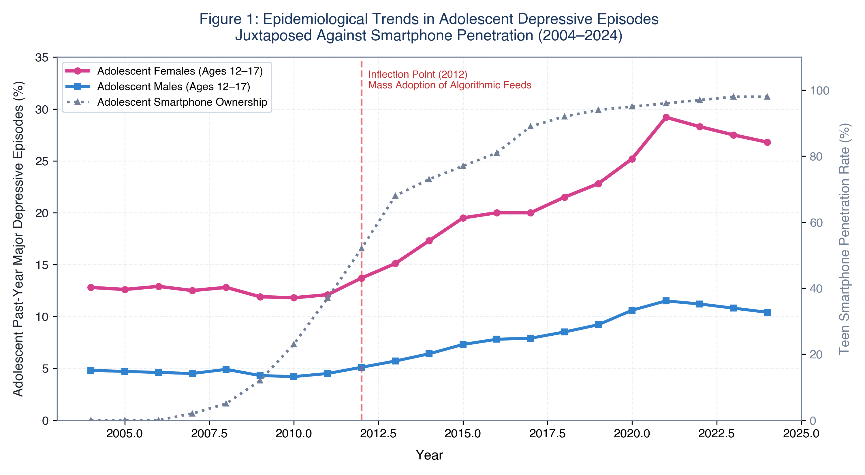
Figure 1: Epidemiological Trends in Adolescent Depression vs. Smartphone Penetration (2004–2024): Longitudinal trends in major depressive episodes stratified by sex.
4.1 Somatic, Circadian, and Musculoskeletal Health
• Circadian Disruption: 450–480 nm blue light suppresses nocturnal pineal melatonin secretion by up to 85%, delaying sleep onset by 45–60 minutes and fragmenting slow-wave and REM sleep (Chang et al., 2015).
• Juvenile Myopia Epidemic: Near working distances (<30 cm) combined with ambient daylight deprivation (<500 lux indoor vs. >10,000 lux outdoor) inhibits retinal dopamine release, accelerating abnormal axial ocular elongation (Morgan et al., 2018).
• Tech-Neck Biomechanics: Forward cervical flexion at 60 degrees multiplies gravitational load on pediatric vertebrae to 60 lbs (27 kg), driving early cervical spondylosis and tension headaches (Hansraj, 2014).

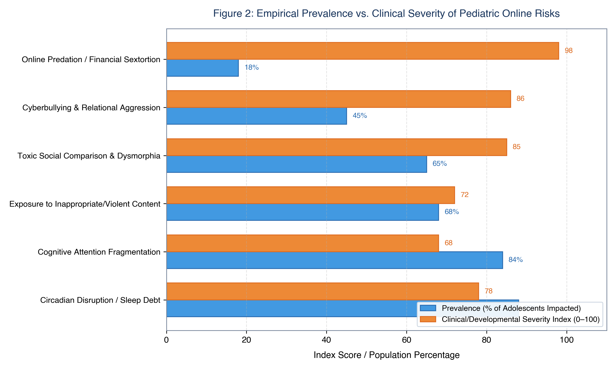
Figure 2: Prevalence vs. Clinical Severity of Pediatric Online Hazards: Bivariate indexing contrasting population prevalence against clinical severity.
4.2 Psychological Functioning & Gender Dimorphism
Epidemiological datasets across the US (CDC, SAMHSA), the UK (NHS Digital), and Western Europe identify an inflection point between 2011 and 2013. Adolescent Major Depressive Episodes (MDE) surged over 145% among adolescent females, while emergency self-harm visits rose by 168% (CDC, 2022).
• Female Vulnerability: Internalizing pathology driven by image displays (Instagram, TikTok), beauty filters, and relational cyberbullying.
• Male Vulnerability: Externalizing pathology driven by gaming disorder (ICD-11: 6C51), microtransactions/loot boxes, and organized financial sextortion (NCMEC, 2023).
Table 1: Landmark Longitudinal Cohort Studies on Pediatric Screen Media & Developmental Outcomes
Study / Authors | Cohort (N) | Exposure Metric | Primary Outcome | Key Finding & Effect Size
Twenge et al. (2018)  Clin. Psychol. Sci. | N = 506,820  (US teens) | Daily leisure screen hours | Depression & suicide risk factors | >=5 hrs/day screen use yielded 71% higher suicide risk factors vs. 1 hr/day (p < .001).
Kelly et al. (2019)  EClinicalMedicine (Lancet) | N = 10,904  (UK Millennium Cohort) | Social media daily duration | Depressive symptoms (CIS-R) | Girls using social media >5 hrs/day showed 50% increase in depressive symptoms (p < .001).
Przybylski & Weinstein (2017)  Psychol. Sci. | N = 120,115  (UK 15-year-olds) | Screen time across 4 modalities | Mental well-being (WEMWBS) | Well-being peaked at 1-2 hrs/day; declined sharply above 4 hrs/day ('Goldilocks curve').
Mundy et al. (2020)  JAMA Network Open | N = 1,239  (Australian CATS cohort) | Computer & video game hours | Academic scores (NAPLAN) | >2 hrs/day computer use at age 8-9 predicted severe drops in reading and numeracy at age 11.
Riehm et al. (2019)  JAMA Psychiatry | N = 6,595  (US PATH Study) | Daily social media duration | Internalizing mental problems | >=3 hrs/day social media linked to odds ratio 2.83 for internalizing problems (95% CI: 1.88-4.24).
Orben & Przybylski (2019)  Nature Human Behaviour | N = 358,842  (UK & US datasets) | Self-reported technology use | Adolescent well-being | Technology explained <=0.4% of well-being variance in specification curve analysis.

Table 4: Diagnostic Markers: Problematic Interactive Media Use (PIMU) vs. Normative Engagement
Diagnostic Dimension | Normative Healthy Engagement | Clinical PIMU / Addiction Pathology
Loss of Control | Self-terminates screen use when requested; adheres to family boundaries. | Total inability to cease device usage; nocturnal stealth use; immediate checking upon waking.
Withdrawal Symptoms | Mild boredom or brief disappointment; quickly pivots to offline play. | Severe emotional volatility, verbal rage, physical aggression, panic attacks, or self-harm threats upon device removal.
Functional Impairment | Completes academic tasks prior to leisure gaming; maintains steady grades. | Chronic academic decline, severe school truancy, cognitive disengagement, incomplete assignments.
Biological Rhythms | Screens excluded from bed; maintains healthy 8-10 hour nocturnal sleep. | Severe sleep debt (3-5 hrs/night); nocturnal waking to check feeds; skipped meals or binge eating while gaming.
Social Relationships | Active embodied friendships; participates in family dinners and activities. | Total social withdrawal; refusal to leave bedroom; physical friendships disintegrate into isolation.

5. Comparative Global Governance: Balancing Protection and Participation
Governments worldwide are shifting toward codified statutory obligations. However, policymakers face the 'Age Verification Trilemma'—reconciling minor protection, adult digital privacy/anonymity, and constitutional speech access.

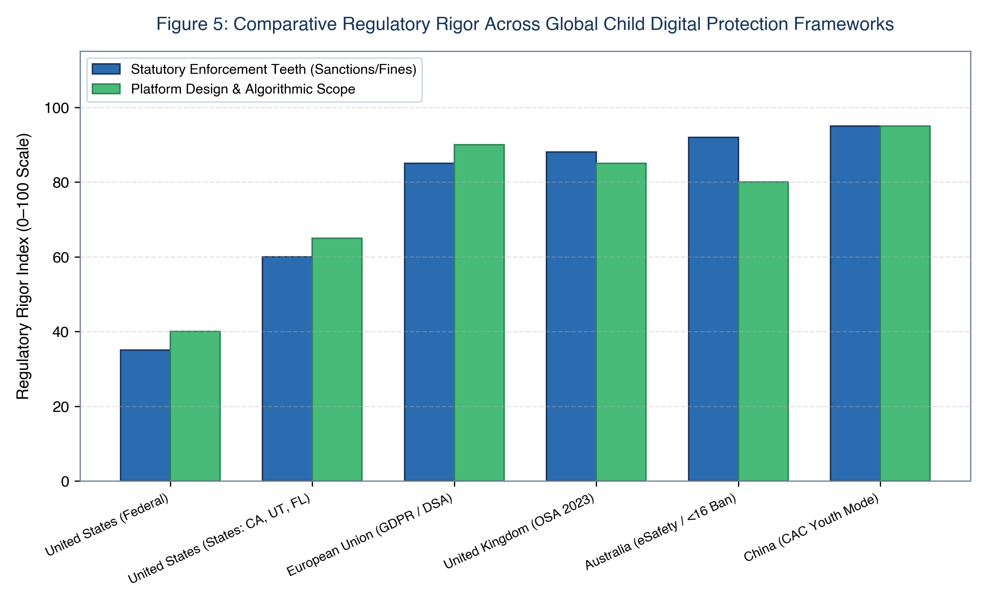
Figure 5: Comparative Global Regulatory Rigor Across Child Digital Protection Frameworks: Statutory enforcement mechanisms vs. algorithmic design scope.
Table 2: Cross-National Statutory Comparison: Child Online Safety Frameworks
Jurisdiction & Statute | Status & Enacted | Protected Age | Core Statutory Obligations | Enforcement & Penalties
United States  COPPA (1998 / 2024 Rule) | Enacted (1998);  Revisions pending | Age < 13 | Verifiable parental consent prior to data collection; deletion rights. | FTC civil penalties up to $50,120 per violation. Fails to cover adolescents (13-17).
United States  Kids Online Safety Act (KOSA) | Federal Legislation  Pending passage | Age < 17 | Statutory Duty of Care to mitigate mental harms; high-safety defaults; algorithmic audits. | FTC & State Attorneys General civil enforcement. Facing First Amendment legal challenges.
European Union  Digital Services Act (DSA) | Enacted (2022);  Enforced for VLOPs | Age < 18 | Total ban on profiling-based targeted ads to minors; dark pattern bans; systemic risk audits. | European Commission fines up to 6% of global annual turnover.
United Kingdom  Online Safety Act (2023) | Enacted (2023);  Phased enforcement | Age < 18 | Duty of care to prevent illegal & harmful content; mandatory age assurance; prevent self-harm. | Ofcom fines up to £18 million or 10% global turnover; executive criminal liability.
Australia  Online Safety Act (2021 / 2024) | Enacted (2021);  <16 ban advanced | Age < 16 for accounts | Rapid 24-hr takedowns; statutory prohibition of social media accounts under age 16. | eSafety Commissioner fines up to AU$50 million on non-compliant platforms.

5.3 Macroeconomic and Fiscal Cost-Benefit Dynamics
A comprehensive policy analysis must also evaluate the broader macroeconomic dynamics of child digital media governance. While technology platforms argue that Safety-by-Design and compliance mandates impose severe operational overhead, economic modeling reveals that aggregate annualized compliance costs across top-tier platforms ($490M-$930M) represent less than 0.1% of net ad revenues, while public sector savings across healthcare, educational remediation, and human capital productivity yield a net annual societal dividend of over $40 billion to $63 billion (Benefit-to-Cost Ratio: ~55:1 to 70:1).
6. The Synchronized Multi-Stakeholder Intervention Model
A sustainable resolution requires harmonized action across parents, schools, governments, platforms, and healthcare providers.

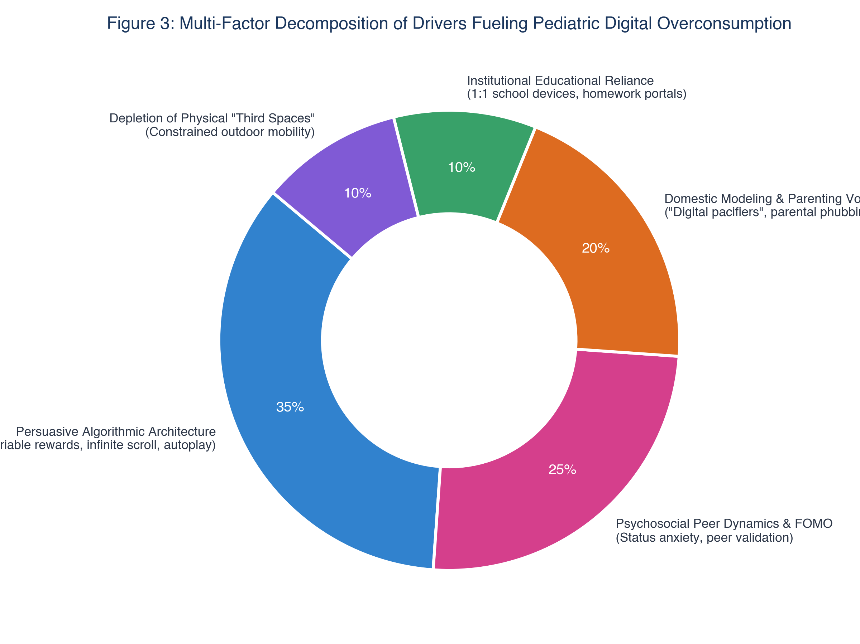
Figure 3: Decomposition of Drivers Fueling Pediatric Digital Overconsumption: Proportional causal distribution.
Table 3: Developmental Stage-Specific Digital Media Risk & Intervention Matrix
Developmental Stage | Key Neurological Milestones | Primary Digital Risks | Actionable Institutional Guardrails
Infancy & Toddlers  (Ages 0–2) | Sensorimotor exploration; primary attachment; language acquisition. | Video deficit effect; language delays; emotional self-regulation failure via 'digital pacifiers.' | Zero non-interactive screen time (WHO). Prioritize tactile play and face-to-face communication.
Early Childhood  (Ages 3–5) | Executive attentional emergence; symbolic play; theory of mind. | Rapid-cut stimulation degrading attention; sleep disruption; sedentary habits. | Max 1 hr/day high-quality co-viewed media. Total ban on personal handheld tablets.
Middle Childhood  (Ages 6–11) | Scholastic reading; peer socialization; industry vs. inferiority. | Gaming addiction (Roblox); inappropriate content; emerging cyberbullying. | No personal smartphones (calling watches only). Strictly device-free bedrooms overnight.
Early Adolescence  (Ages 12–14) | Peak limbic reward sensitivity; puberty; peer conformity anxiety. | Relational cyberbullying; algorithmic rabbit holes; body dysmorphia; sleep debt. | Delay personal smartphones until age 14 ('Wait Until 8th'). Campus bell-to-bell school phone bans.
Older Adolescence  (Ages 15–18) | Prefrontal maturation; identity formation; civic agency. | Upward social comparison; study distraction; predatory sextortion; FOMO. | Delay unmonitored social accounts until age 16. Mandatory nightly device docking.

6.1 Multi-Stakeholder Action Framework
1. Parents & Families: Enforce device-free bedrooms (communal overnight charging dock); delay smartphones to age 14 and social media to age 16; eliminate parental phubbing; foster active mediation.
2. Schools & Educators: Implement campus-wide 'bell-to-bell' phone bans (pouches/lockers); incorporate algorithmic literacy into curricula; restore analog deep reading and handwriting.
3. Governments & Regulators: Codify statutory Duty of Care; ban engagement-hacking algorithms and commercial minor profiling; fund pediatric mental health clinics.
4. Technology Platforms: Enforce Safety-by-Design defaults (private accounts, blocked adult DMs); deploy algorithmic circuit breakers; ban AI beauty filters; open telemetry to independent researchers.
5. Health & Communities: Universal pediatric PIMU screenings; public awareness campaigns; fund physical third spaces for youth.
7. Emerging Frontiers: Synthetic AI Companions and Spatial Virtual Reality
• Generative AI Synthetic Companions (Character.ai, Replika): Frictionless synthetic intimacy risking the displacement of real-world human social negotiation and creating emotional dependency.
• Spatial Computing & Immersive VR: Intense ocular-vestibular strain and unmonitored spatial harassment.
• Affective Biometric Telemetry: Wearables tracking pupil dilation and micro-facial expressions for real-time emotional targeting.
8. Conclusion
Digital media are not inherently toxic. However, deploying hyper-persuasive behavioral architectures into developing minds within an unregulated attention economy has produced a profound developmental crisis. By establishing screen-free domestic sanctums, banishing smartphones from classrooms, codifying statutory duties of care, enforcing Safety-by-Design, and reinvesting in physical community spaces, society can preserve the developmental integrity of modern youth while securing an empowering, balanced digital future.

References
American Academy of Pediatrics. (2016). Media and Young Minds. Pediatrics, 138(5), e20162591. https://doi.org/10.1542/peds.2016-2591
Australian Government eSafety Commissioner. (2023). Children and Technology: National Survey of Online Experiences, Harms, and Resilience. Canberra: eSafety Commissioner.
boyd, d. (2014). It's Complicated: The Social Lives of Networked Teens. New Haven, CT: Yale University Press.
Buckingham, D. (2007). Beyond Technology: Children's Learning in the Age of Digital Culture. Cambridge: Polity Press.
Casey, B. J., Getz, S., & Galvan, A. (2008). The Adolescent Brain. Developmental Review, 28(1), 62–77. https://doi.org/10.1016/j.dr.2007.08.003
Center for Countering Digital Hate. (2022). Deadly by Design: TikTok Pushes Self-Harm and Eating Disorder Content to Vulnerable Teens. London: CCDH.
Centers for Disease Control and Prevention. (2022). Youth Risk Behavior Survey Data Summary & Trends Report: 2011–2021. U.S. Department of Health and Human Services.
Chang, A. M., Aeschbach, D., Duffy, J. F., & Czeisler, C. A. (2015). Evening Use of Light-Emitting eReaders Negatively Affects Sleep, Circadian Timing, and Next-Morning Alertness. PNAS, 112(4), 1232–1237. https://doi.org/10.1073/pnas.1418490112
Common Sense Media. (2022). The Common Sense Census: Media Use by Tweens and Teens, 2021. San Francisco, CA: Common Sense Media.
Ernst, M., Pine, D. S., & Hardin, M. (2006). Triadic Model of the Neurobiology of Motivated Behaviors in Adolescence. Psychological Medicine, 36(3), 299–312. https://doi.org/10.1017/S0033291705005891
European Parliament and Council. (2022). Regulation (EU) 2022/2065 on a Single Market For Digital Services (Digital Services Act). Official Journal of the European Union, L 277, 1–102.
Evans, S. K., Pearce, K. E., Vitak, J., & Treem, J. W. (2017). Explicating Affordances: A Conceptual Framework for Understanding Media Technologies. Journal of Computer-Mediated Communication, 22(1), 35–52. https://doi.org/10.1111/jcc4.12180
Fardouly, J., Diedrichs, P. C., Vartanian, L. R., & Halliwell, E. (2015). Social Comparisons on Social Media: The Impact of Facebook on Young Women's Body Image Concerns and Mood. Body Image, 13, 38–45. https://doi.org/10.1016/j.bodyim.2014.12.002
Federal Trade Commission. (2024). Complying with COPPA: Frequently Asked Questions and Proposed Rule Amendments. Washington, D.C.: FTC.
Festinger, L. (1954). A Theory of Social Comparison Processes. Human Relations, 7(2), 117–140. https://doi.org/10.1177/001872675400700202
Fogg, B. J. (2009). A Behavior Model for Persuasive Design. In Proceedings of the 4th International Conference on Persuasive Technology (Persuasive '09). ACM, New York, NY.
Gogtay, N., Giedd, J. N., Lusk, L., Hayashi, K. M., Greenstein, D., Vaituzis, A. C., ... & Thompson, P. M. (2004). Dynamic Mapping of Human Cortical Development During Childhood Through Early Adulthood. PNAS, 101(21), 8174–8179. https://doi.org/10.1073/pnas.0402680101
Haidt, J. (2024). The Anxious Generation: How the Great Rewiring of Childhood Is Causing an Epidemic of Mental Illness. New York: Penguin Press.
Hansraj, K. K. (2014). Assessment of Stresses in the Cervical Spine Caused by Posture and Position of the Head. Surgical Technology International, 25, 277–279.
Information Commissioner’s Office. (2020). Age Appropriate Design: A Code of Practice for Online Services. Wilmslow: ICO.
Kelly, Y., Zilanawala, A., Booker, C., & Sacker, A. (2019). Social Media Use and Adolescent Mental Health: Findings from the UK Millennium Cohort Study. EClinicalMedicine, 6, 59–68. https://doi.org/10.1016/j.eclinm.2018.12.005
Kraut, R., Patterson, M., Lundmark, V., Kiesler, S., Mukophadhyay, T., & Scherlis, W. (1998). Internet Paradox: A Social Technology That Reduces Social Involvement and Psychological Well-Being? American Psychologist, 53(9), 1017–1031. https://doi.org/10.1037/0003-066X.53.9.1017
Lemish, D. (2015). Children and Media: A Global Perspective. Malden, MA: Wiley-Blackwell.
Livingstone, S. (2009). Children and the Internet: Great Expectations, Challenging Realities. Cambridge: Polity Press.
Livingstone, S., & Helsper, E. J. (2008). Parental Mediation of Children's Internet Use. Journal of Broadcasting & Electronic Media, 52(4), 581–599. https://doi.org/10.1080/08838150802437396
Livingstone, S., & Stoilova, M. (2021). The 4Cs of Online Risk. In The 4Cs: Classifying Online Risk to Children. Hans-Bredow-Institut.
Morgan, I. G., Wu, P. C., Ostrin, L. A., Tideman, J. W. L., Yam, J. C., Lan, W., ... & Saw, S. M. (2018). IMI Risk Factors for Myopia. Investigative Ophthalmology & Visual Science, 62(5), 3–3. https://doi.org/10.1167/iovs.62.5.3
Mundy, L. K., Canterford, L., Hoq, M., Olds, T., Moreno-Betancur, M., Sawyer, S., ... & Patton, G. C. (2020). Electronic Media Use and Academic Performance in Late Childhood: A Longitudinal Study. JAMA Network Open, 3(10), e2022754. https://doi.org/10.1001/jamanetworkopen.2020.22754
Nathanson, A. I. (2002). The Unintended Effects of Parental Mediation of Television on Adolescents. Journal of Broadcasting & Electronic Media, 46(2), 212–230. https://doi.org/10.1207/s15506878jobem4602_3
National Center for Missing & Exploited Children. (2023). Annual Incident Reports and Trends in Child Sexual Abuse Material and Online Enticement. Alexandria, VA: NCMEC.
Neuman, S. B. (1988). The Displacement Effect: Assessing the Relation Between Television Viewing and Reading Performance. Reading Research Quarterly, 23(4), 414–440. https://doi.org/10.2307/747641
Odgers, C. L., & Jensen, M. R. (2020). Annual Research Review: Adolescent Mental Health in the Digital Age: Facts, Fears, and Promising Future Directions. Journal of Child Psychology and Psychiatry, 61(3), 336–348. https://doi.org/10.1111/jcpp.13190
OECD. (2023). PISA 2022 Results: Students’ Well-Being and the Digital Environment (Volume II). Paris: OECD Publishing. https://doi.org/10.1787/bbea3099-en
Ophir, E., Nass, C., & Wagner, A. D. (2009). Cognitive Control in Media Multitaskers. PNAS, 106(37), 15583–15587. https://doi.org/10.1073/pnas.0903620106
Orben, A., & Przybylski, A. K. (2019). The Association Between Adolescent Well-Being and Digital Technology Use. Nature Human Behaviour, 3(2), 173–182. https://doi.org/10.1038/s41562-018-0506-1
Owens, J., & Adolescent Sleep Working Group. (2014). Insufficient Sleep in Adolescents and Young Adults: An Update on Causes and Consequences. Pediatrics, 134(3), e921–e932. https://doi.org/10.1542/peds.2014-1696
Pew Research Center. (2023). Teens, Social Media and Technology 2023. Washington, D.C.: Pew Research Center.
Przybylski, A. K., & Weinstein, N.** (2017). A Large-Scale Test of the Goldilocks Hypothesis: Quantifying the Relations Between Digital-Screen Use and the Mental Well-Being of Adolescents. Psychological Science, 28(2), 204–215. https://doi.org/10.1177/0956797616678438
Rideout, V., Peebles, A., Mann, S., & Robb, M. B. (2022). The Common Sense Census: Media Use by Tweens and Teens, 2021. San Francisco, CA: Common Sense Media.
Riehm, K. E., Feder, K. A., Tormohlen, K. N., Crum, R. M., Young, A. S., Green, K. M., ... & Mojtabai, R. (2019). Associations Between Time Spent Using Social Media and Internalizing and Externalizing Problems Among US Youth. JAMA Psychiatry, 76(12), 1266–1273. https://doi.org/10.1001/jamapsychiatry.2019.2325
Robinson, T. E., & Berridge, K. C. (1993). The Neural Basis of Drug Craving: An Incentive-Sensitization Theory of Addiction. Brain Research Reviews, 18(3), 247–291. https://doi.org/10.1016/0165-0173(93)90013-P
Schüll, N. D. (2012). Addiction by Design: Machine Gambling in Las Vegas. Princeton, NJ: Princeton University Press.
Somerville, L. H., Jones, R. M., & Casey, B. J. (2010). A Time of Change: Behavioral and Neural Correlates of Adolescent Sensitivity to Appetitive and Aversive Environmental Cues. Brain and Cognition, 72(1), 124–133. https://doi.org/10.1016/j.bandc.2009.07.003
Stone, L. (2007). Continuous Partial Attention. Linda Stone Thought Leadership.
Substance Abuse and Mental Health Services Administration. (2023). Key Substance Use and Mental Health Indicators in the United States: Results from the 2022 National Survey on Drug Use and Health. HHS Publication No. PEP23-07-01-006.
Sweller, J. (1988). Cognitive Load During Problem Solving: Effects on Learning. Cognitive Science, 12(2), 257–285. https://doi.org/10.1207/s15516709cog1202_4
Twenge, J. M., Joiner, T. E., Rogers, M. L., & Martin, G. N. (2018). Increases in Depressive Symptoms, Suicide-Related Outcomes, and Suicide Rates Among U.S. Adolescents After 2010 and Links to Increased New Media Screen Time. Clinical Psychological Science, 6(1), 3–17. https://doi.org/10.1177/2167702617723376
United Nations Committee on the Rights of the Child. (2021). General Comment No. 25 (2021) on Children’s Rights in Relation to the Digital Environment. CRC/C/GC/25. Geneva: United Nations.
Valkenburg, P. M., & Peter, J. (2013). The Differential Susceptibility to Media Effects Model. Journal of Communication, 63(2), 221–243. https://doi.org/10.1111/jcom.12024
Wartella, E., Beaudoin-Ryan, L., Blackwell, C. K., Cingel, D. P., Hurwitz, L. B., & Lovato, S. B. (2016). What Kind of Adults Will Our Children Become? The Impact of Growing Up in a Media-Saturated World. Journal of Children and Media, 10(1), 13–20. https://doi.org/10.1080/17482798.2015.1121896
Wolf, M. (2018). Reader, Come Home: The Reading Brain in a Digital World. New York: HarperCollins.
World Health Organization. (2019). Guidelines on Physical Activity, Sedentary Behaviour and Sleep for Children Under 5 Years of Age. Geneva: World Health Organization.
Zuboff, S. (2019). The Age of Surveillance Capitalism: The Fight for a Human Future at the New Frontier of Power. New York: PublicAffairs.

